Coloring book pictures only . .

If you are unable to open the Publisher file use these images and the PDF as a guide to create your own coloring book.

Have fun!

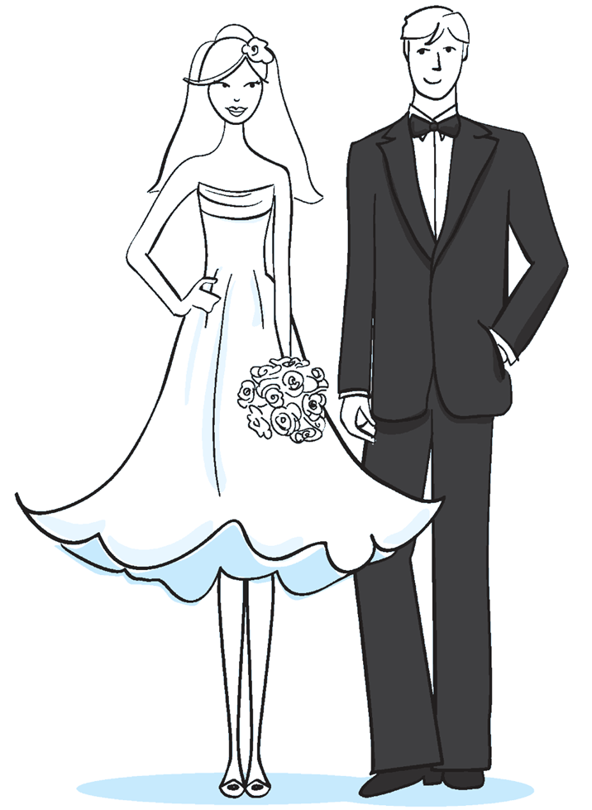



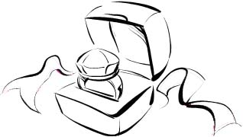





SO00782_

j0151089[1]









